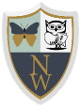
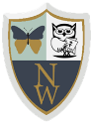
Newhampton Church of England Primary School Science Knowledge Organiser
The Unit: Using our Senses Focus: Animals Including Humans
