Newhampton Church of England Schools Federation Curriculum Overview
“Let Your Light Shine”
Early Years Foundation Stage
There are seven areas of learning and development that shape our EYFS educational programme. All areas of learning and development are important and inter-connected.
We consider the individual needs, interests, and development of every child in our care and use this information to plan challenging, enjoyable experiences for each child in respect of each of the areas of learning and development.
Three characteristics of effective teaching and learning are:
Playing and Exploring- Children investigate and experience things, and ‘have a go’
Active Learning- Children concentrate and keep on trying if they encounter difficulties, and enjoys achievements Creating and Thinking Critically- Children have and develop their own ideas, make links between ideas, and develop strategies for doing things

EYFS  2 Year Rolling Plan | Cycle A |  |  |  |  |  |  |  | Cycle B
 | Autumn  1 |  | Autumn  2 | Spring  1 |  | Spring  2 | Summer  1 | Summer  2 | Autumn  1 | Autumn  2 |  |  | Spring  1 | Spring  2 |  | Summer  1 |  | Summer  2
Quality Text Driver | The Something |  | Star in the Jar | Little Red |  | The Extraordinary Gardener | Juniper Jupiter | The Storm Whale | The  Something | Star in the Jar |  |  | Little Red | The Extraordinary Gardener |  | Juniper Jupiter |  | The Storm Whale
 | 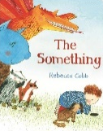 |  | 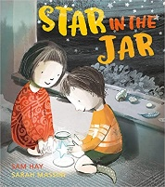 | 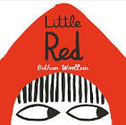 |  | 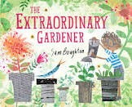 | 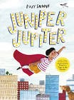 | 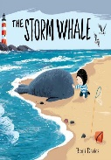 |  |  |  |  |  | 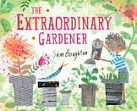
Steps to Read | Friendship and Animals |  | Stars and Space | Traditional Tales |  | Growing | Superheroes | Seaside | Friendship  and Animals | Stars and  Space |  |  | Traditional Tales | Growing |  | Superheroes |  | Seaside
Communication and Language | Understand how to listen carefully and why listening is important  Engage in story times  Develop social phrases  Children will know and retell The Something (Autumn 1) and Star in the Jar (Autumn 2) |  |  | Articulate their ideas and thoughts in well-formed sentences.  Connect one idea or action to another using a range of connectives.  Describe events in some detail  Use talk to help work out problems and organise thinking and activities explain how things work and why they might happen.  Children will know and retell Little Red (Spring 1) and The Extraordinary Gardener (Spring 2) |  |  | Listen to and talk about texts to build familiarity and understanding.  Retell the story once they have developed a deep familiarity with the text; some as exact repetition and some in their own words and ideas.  Children will know and retell The Extraordinary Gardener (Summer 1) and the Storm Whale (Summer 2) |  | Understand how to listen carefully and why listening is important  Engage in story times  Develop social phrases  Children will know and retell The Something (Autumn 1) and Star in the Jar (Autumn 2) |  |  |  | Articulate their ideas and thoughts in well-formed sentences.  Connect one idea or action to another using a range of connectives.  Describe events in some detail  Use talk to help work out problems and organise thinking and activities explain how things work and why they might happen.  Children will know and retell Little Red (Spring 1) and The Extraordinary Gardener (Spring 2) |  |  | Listen to and talk about texts to build familiarity and understanding.  Retell the story once they have developed a deep familiarity with the text; some as exact repetition and some in their own words and ideas.  Children will know and retell Juniper Jupiter (Summer 1) and the Storm Whale (Summer 2)
 | Learn new vocabulary Use new vocabulary in different contexts  Listen carefully to rhymes and songs, paying attention to how they sound  Use new vocabulary throughout the day Learn rhymes, poems, and songs  Ask questions to find out more and to check understanding Engage in arrange of genres |  |  |  |  |  |  |  | Learn new vocabulary Use new vocabulary in different contexts  Listen carefully to rhymes and songs, paying attention to how they sound  Use new vocabulary throughout the day Learn rhymes, poems, and songs  Ask questions to find out more and to check understanding Engage in arrange of genres
Golden Thread | To engage in conversations with adults and peers using a rich range of vocabulary |  |  |  |  |  |  |  | To engage in conversations with adults and peers using a rich range of vocabulary
Personal, Social and Emotional Development | See themselves as a valuable individual  Build constructive and respectful relationships  Express their feelings and consider the feelings of others  Children will know how regular exercise is important for their health  Children will now how healthy eating is important for their health |  |  | Show resilience and perseverance in the face of challenge  Identify and moderate their own feelings socially and emotionally  Children will know how regular toothbrushing is important for their health  Children will know what a sensible amount of screen time is and why this important for their health |  |  | Think about the perspectives of others  Manage their own needs  Children will know about the importance of a good sleep routine for their health  Children will know how to be a safe pedestrian and why this important |  | See themselves as a valuable individual  Build constructive and respectful relationships  Express their feelings and consider the feelings of others  Children will know how regular exercise is important for their health  Children will now how healthy eating is important for their health |  |  |  | Show resilience and perseverance in the face of challenge  Identify and moderate their own feelings socially and emotionally  Children will know how regular toothbrushing is important for their health  Children will know what a sensible amount of screen time is and why this important for their health |  |  | Think about the perspectives of others  Manage their own needs  Children will know about the importance of a good sleep routine for their health  Children will know how to be a safe pedestrian and why this important
 | NB. These statements have been split for extra focus, but all will apply on an ongoing basis throughout the reception year  Children will know our school rules and values – Be ready, Be safe, Be respectful Children will know and talk about different factors that support their overall health and wellbeing |  |  |  |  |  |  |  | NB. These statements have been split for extra focus, but all will apply on an ongoing basis throughout the reception year  Children will know our school rules and values – Be ready, Be safe, Be respectful Children will know and talk about different factors that support their overall health and wellbeing
Golden Threads | To be able to build good relationships with adults and peers  To understand a range of emotions, recognising challenges they might face and how to overcome them  To know ways to keep healthy |  |  |  |  |  |  |  | To be able to build good relationships with adults and peers  To understand a range of emotions, recognising challenges they might face and how to overcome them  To know ways to keep healthy
Physical Development | Further develop the skills they need to manage the school day successfully: lining up, queuing, mealtimes, personal hygiene  Revise and refine the fundamental movement skills they have already acquired: rolling, crawling, walking, jumping, running, hopping, skipping, climbing  Begin to hold a pencil effectively in preparation for fluent writing |  |  | Further develop and refine a range of ball skills including throwing, catching, kicking, passing, batting, and aiming.  Develop confidence, competence, precision, and accuracy when engaging in activities that involve a ball  Hold a pencil securely and effectively in preparation for fluent writing – using the tripod grip in most cases |  |  | Combine different movements with ease and fluency  Develop the foundations of a handwriting style which is fast, accurate and efficient  Confidently and safely use a range of large and small apparatus indoors and outside, alone and in a group  Swimming  Hold a pencil effectively in preparation for writing in Year 1.  Begin to show accuracy and care when drawing |  | Further develop the skills they need to manage the school day successfully: lining up, queuing, mealtimes, personal hygiene  Revise and refine the fundamental movement skills they have already acquired: rolling, crawling, walking, jumping, running, hopping, skipping, climbing  Begin to hold a pencil effectively in preparation for fluent writing |  |  |  | Further develop and refine a range of ball skills including throwing, catching, kicking, passing, batting, and aiming.  Develop confidence, competence, precision, and accuracy when engaging in activities that involve a ball  Hold a pencil securely and effectively in preparation for fluent writing – using the tripod grip in most cases |  |  | Combine different movements with ease and fluency  Develop the foundations of a handwriting style which is fast, accurate and efficient  Confidently and safely use a range of large and small apparatus indoors and outside, alone and in a group  Swimming  Hold a pencil effectively in preparation for writing in Year 1.  Begin to show accuracy and care when drawing
 | Develop the overall body strength, co-ordination, balance, and agility needed to engage successfully with future physical education sessions and other physical disciplines including dance, gymnastics, sport and swimming  Develop their small motor skills so that they can use a range of tools competently, safely, and confidently. Suggested tools: pencils for drawing and writing, paintbrushes, scissors, knives, forks and spoon  Use their core muscle strength to achieve a good posture when sitting at a table or sitting on the floor  Develop overall body-strength, balance, co-ordination and agility |  |  |  |  |  |  |  | Develop the overall body strength, co-ordination, balance, and agility needed to engage successfully with future physical education sessions and other physical disciplines including dance, gymnastics, sport and swimming  Develop their small motor skills so that they can use a range of tools competently, safely, and confidently. Suggested tools: pencils for drawing and writing, paintbrushes, scissors, knives, forks and spoon  Use their core muscle strength to achieve a good posture when sitting at a table or sitting on the floor  Develop overall body-strength, balance, co-ordination and agility
Golden Thread | To use gross and fine motor skills with control and confidence |  |  |  |  |  |  |  | To use gross and fine motor skills with control and confidence
Literacy | Read individual letters by saying the sounds for them  Children will begin to form lower-case and capital letters  Children will know how to write their name  Blend sounds into words to read short words made up of known letter-sound correspondences  Read a few common exception words matched to the school’s phonic programme  Read simple phrases made up of words with known letter - sound correspondences and, where necessary, a few exception words |  |  | Read some letter groups that each represent one sound and say sounds for them  Read simple sentences made up of words with known letter - sound correspondences and, where necessary, a few exception words |  |  | Form lower-case and capital letters correctly  Spell words by identifying the sounds and then writing the sound with letter/s  Write short sentences with words with known letter-sound correspondences using a capital letter and full stop  Re-read what they have written to check that it makes sense |  | Read individual letters by saying the sounds for them  Children will begin to form lower-case and capital letters  Children will know how to write their name  Blend sounds into words to read short words made up of known letter-sound correspondences  Read a few common exception words matched to the school’s phonic programme  Read simple phrases made up of words with known letter - sound correspondences and, where necessary, a few exception words |  |  |  | Read some letter groups that each represent one sound and say sounds for them  Read simple sentences made up of words with known letter - sound correspondences and, where necessary, a few exception words |  |  | Form lower-case and capital letters correctly  Spell words by identifying the sounds and then writing the sound with letter/s  Write short sentences with words with known letter-sound correspondences using a capital letter and full stop  Re-read what they have written to check that it makes sense
Ready Steady Phonics | Phase 1 assessment  Phase 2 | Phase 2  Phase 3 |  | Phase 3 |  |  | Phase 3 Phase 4 | Phase 4 | Phase 1 assessment  Phase 2 |  | Phase 2  Phase 3 |  | Phase 3 |  |  | Phase 3 Phase 4 | Phase 4
 | Spell words by identifying known letter sounds Children will read and re-read a selection of books developing fluency, understanding and enjoyment |  |  |  |  |  |  |  | Spell words by identifying known letter sounds Children will read and re-read a selection of books developing fluency, understanding and enjoyment
Golden Threads | Reading: To enjoy reading a range of texts  To understand and talk about a range of texts, including fiction, non-fiction, rhymes and poems  To decode unfamiliar words and recognise familiar words  Writing: To articulate what they want to write and to spell words phonetically  To enjoy writing for a variety of purposes |  |  |  |  |  |  |  | Reading: To enjoy reading a range of texts  To understand and talk about a range of texts, including fiction, non-fiction, rhymes and poems  To decode unfamiliar words and recognise familiar words  Writing: To articulate what they want to write and to spell words phonetically  To enjoy writing for a variety of purposes
Mathematics | Numbers to 5  Comparing groups within 5  2D and 3D shape  Change within 5  Number bonds within 5  Spacial awareness |  |  |  | Numbers to 10  Comparing numbers within 10  Addition to 10  Measure – Length, height and weight  Number bonds to 10  Subtraction  Exploring patterns |  | Counting on and counting back  Numbers to 20  Numerical patterns  Shape (Compose, decompose and rotate shape)  Measure (Volume and capacity)  Sorting  Time |  | Numbers to 5  Comparing groups within 5  2D and 3D shape  Change within 5  Number bonds within 5  Spacial awareness |  |  | Numbers to 10  Comparing numbers within 10  Addition to 10  Measure – Length, height and weight  Number bonds to 10  Subtraction  Exploring patterns |  |  | Counting on and counting back  Numbers to 20  Numerical patterns  Shape (Compose, decompose and rotate shape)  Measure (Volume and capacity)  Sorting  Time
 | Children will develop the ability to subitise  Verbally count beyond 20 recognising the pattern of the counting system  Link the number symbol with its cardinal number value Automatically recall number bonds for number 0-5 and some to 10 |  |  |  |  |  |  |  | Children will develop the ability to subitise  Verbally count beyond 20 recognising the pattern of the counting system  Link the number symbol with its cardinal number value Automatically recall number bonds for number 0-5 and some to 10
Golden Threads | To understand numbers to ten  To be able to use their knowledge of maths, including space, shape and measures, in the real world  To enjoy investigating, talking about and exploring numbers, shape, space and measures |  |  |  |  |  |  |  | To understand numbers to ten  To be able to use their knowledge of maths, including space, shape and measures, in the real world  To enjoy investigating, talking about and exploring numbers, shape, space and measures
Understanding The World  Past and Present | Children will know how they have changed from being a baby to being 4/5  Children will know things have changed over time  Children will know the past is anything before the present day  Children will know that houses are different  Comment on images of familiar situations in the past |  |  |  |  |  |  |  | Children will know how they have changed from being a baby to being 4/5  Children will know things have changed over time  Children will know the past is anything before the present day  Children will know that houses are different  Comment on images of familiar situations in the past
Understanding The World  People, Culture and Communities | Children will recognise that people have different beliefs and celebrate special times in different ways: Diwali, Harvest, Remembrance, Christmas  Children will describe their immediate environment using knowledge from observation, discussion, stories and maps  Negotiate pathways through areas of school, naming different features. (Eg: Photos of items around the school, children to locate them, walk around school)  Talk about the differences between people around them  Use the local area for exploring both the built and the natural environment.  Express their opinions on natural and built environments (Eg: Forest School sessions, walk around school)  Talk about differences within own local environment |  |  |  | Recognise some similarities between life in this country and life in other countries  Know some similarities and differences between different religious and cultural communities in this country (eg: Easter Chinese New Year, Ramadan)  Know some similarities and differences between religious and cultural communities in this country, drawing on their experiences and what has been read in class (Link to Handa’s Surprise)  Discuss and explain similarities and differences between life in this country and life in other countries drawing from stories, non- fiction texts and maps  Know that there are different countries in the world and use place names where possible  Use stories and non-fiction texts to find out about life in different place |  | Know that there are different countries in the world and use place names where possible.  Talk about differences within own local environment  Be introduced to the use of symbols, which might be a grey colour for a road and a building shape for a house, to make their own maps of routes or places that they know  Know that there are different countries in the world and use place names where possible  Children will talk about people that they have come across in their community such as fire service, doctors, dentists |  | Children will recognise that people have different beliefs and celebrate special times in different ways: Diwali, Harvest, Remembrance, Christmas  Children will describe their immediate environment using knowledge from observation, discussion, stories and maps  Negotiate pathways through areas of school, naming different features. (Eg: Photos of items around the school, children to locate them, walk around school)  Talk about the differences between people around them  Use the local area for exploring both the built and the natural environment.  Express their opinions on natural and built environments (Eg: Forest School sessions, walk around school)  Talk about differences within own local environment |  |  | Recognise some similarities between life in this country and life in other countries  Know some similarities and differences between different religious and cultural communities in this country (eg: Easter Chinese New Year, Ramadan)  Know some similarities and differences between religious and cultural communities in this country, drawing on their experiences and what has been read in class (Link to Handa’s Surprise)  Discuss and explain similarities and differences between life in this country and life in other countries drawing from stories, non- fiction texts and maps  Know that there are different countries in the world and use place names where possible  Use stories and non-fiction texts to find out about life in different place |  |  | Know that there are different countries in the world and use place names where possible.  Talk about differences within own local environment  Be introduced to the use of symbols, which might be a grey colour for a road and a building shape for a house, to make their own maps of routes or places that they know  Know that there are different countries in the world and use place names where possible  Children will talk about people that they have come across in their community such as fire service, doctors, dentists
Understanding The World  The Natural World | Children will note and record the weather  Children will access a range of texts about the changing seasons  Children will observe how animals behave differently as the seasons change  Children will name and describe some plants and animals  Children will recognise and name some plants and animals  Children will group animals to their own criteria  Children will comment on different animals they have seen whilst outside |  |  |  | Children will name common materials  Children will recognise objects by their material  Children will explain how materials feel and suggest why they are used to make specific objects  Children will group objects based on their physical properties  Children will observe and interact with natural processes and materials (eg: build bed for Goldilocks, house for the three little pigs, bridge for the Gingerbread Man)  Children will be encouraged to make focused observations of the natural world  Children will describe and talk about what plants need to grow  Children will recognise trees compared to plants compared to flowers  Children will understand and talk about the life cycle of a sunflower |  | Children will know how they have changed from being a baby to being 4/5  Children will draw and label parts of the human body including elbows, ankles and some internal body parts  Children will name and identify each sense with their accompanying body  Children will comment on things they have seen whilst outside including plants and animals  Children will name and describe some plants and animals  Children will understand and talk about the life cycle of a butterfly  Children will understand how to care for different animals and what they need |  | Children will note and record the weather  Children will access a range of texts about the changing seasons  Children will observe how animals behave differently as the seasons change  Children will name and describe some plants and animals  Children will recognise and name some plants and animals  Children will group animals to their own criteria  Children will comment on different animals they have seen whilst outside |  |  | Children will name common materials  Children will recognise objects by their material  Children will explain how materials feel and suggest why they are used to make specific objects  Children will group objects based on their physical properties  Children will observe and interact with natural processes and materials (eg: build bed for Goldilocks, house for the three little pigs, bridge for the Gingerbread Man)  Children will be encouraged to make focused observations of the natural world  Children will describe and talk about what plants need to grow  Children will recognise trees compared to plants compared to flowers  Children will understand and talk about the life cycle of a sunflower |  |  | Children will know how they have changed from being a baby to being 4/5  Children will draw and label parts of the human body including elbows, ankles and some internal body parts  Children will name and identify each sense with their accompanying body  Children will comment on things they have seen whilst outside including plants and animals  Children will name and describe some plants and animals  Children will understand and talk about the life cycle of a butterfly  Children will understand how to care for different animals and what they need
 | Understand the effect of changing seasons on the natural world around them Describe what they see, hear and feel whilst outside  Explore the natural world around them Name and describe people who are familiar to them Talk about members of their immediate family and community |  |  |  |  |  |  |  | Understand the effect of changing seasons on the natural world around them Describe what they see, hear and feel whilst outside  Explore the natural world around them Name and describe people who are familiar to them Talk about members of their immediate family and community
Golden Threads | To know that change happens and there are reasons why  To observe, ask questions and explore ways to answer them  To know that different people have different beliefs and celebrations  To know things have happened in the past  To compare similarities and differences of our locality and other places |  |  |  |  |  |  |  | To know that change happens and there are reasons why  To observe, ask questions and explore ways to answer them  To know that different people have different beliefs and celebrations  To know things have happened in the past  To compare similarities and differences of our locality and other places
Expressive Arts and Design  Creating With Materials | Exploring mark making through different drawing materials  Develop the use of tools and joining techniques  Explore sculptural and malleable materials, and natural objects  Design and make clay animal sculptures |  |  |  | Exploring paint and painting techniques through nature, music and collaborative work  Developing creativity through child-led exploration of mixed-media, making collages and transient art  Explore various types of permanent and temporary joins |  | Develop cutting, threading, joining and folding skills  Explore the differences between fruits and vegetables  Prepare fruit kebabs |  | Exploring mark making through different drawing materials  Develop the use of tools and joining techniques  Explore sculptural and malleable materials, and natural objects  Design and make clay animal sculptures |  |  | Exploring paint and painting techniques through nature, music and collaborative work  Developing creativity through child-led exploration of mixed-media, making collages and transient art  Explore various types of permanent and temporary joins |  |  | Develop cutting, threading, joining and folding skills  Explore the differences between fruits and vegetables  Prepare fruit kebabs
Expressive Arts and Design  Being Imaginative and Expressive | Begin to draw from observation using faces, self-portraits and plants as a stimulus  Develop storylines in pretend play  Sing in a group or on their own, increasingly matching the pitch and following the melody  Sing a range of well-known nursery rhymes |  |  |  | Use a combination of materials and joining techniques in the junk modelling area  Repeat simple rhythms  Play instruments finding the beat of a piece of music, sometimes with support |  | Design a fruit kebab  Listen attentively, move to and talk about music, expressing their feelings and responses  Watch and talk about dance and performance art, expressing their feelings and responses |  | Begin to draw from observation using faces, self-portraits and plants as a stimulus  Develop storylines in pretend play  Sing in a group or on their own, increasingly matching the pitch and following the melody  Sing a range of well-known nursery rhymes |  |  | Use a combination of materials and joining techniques in the junk modelling area  Repeat simple rhythms  Play instruments finding the beat of a piece of music, sometimes with support |  |  | Design a fruit kebab  Listen attentively, move to and talk about music, expressing their feelings and responses  Watch and talk about dance and performance art, expressing their feelings and responses
 | Explore, use, and refine a variety of artistic effects to express their ideas and feelings Explore and engage in music making and dance, performing solo or in groups  Return to and build on their previous learning, refining ideas and developing their ability to represent them  Create collaboratively sharing ideas, resources and skills  Sing songs and join in with rhymes and poems about the natural world |  |  |  |  |  |  |  | Explore, use, and refine a variety of artistic effects to express their ideas and feelings Explore and engage in music making and dance, performing solo or in groups  Return to and build on their previous learning, refining ideas and developing their ability to represent them  Create collaboratively sharing ideas, resources and skills  Sing songs and join in with rhymes and poems about the natural world
Golden Thread | To express themselves using imagination and creativity through the arts  To design and construct with a purpose, using and refining as they explore |  |  |  |  |  |  |  | To express themselves using imagination and creativity through the arts  To design and construct with a purpose, using and refining as they explore
Cultural Capital / Trips / Visitors / Enrichment Ideas | Invite parent / baby into school  Walk around the village  Harvest celebration  Diwali – Food tasting, Bollywood dancing, Rangoli patterns  Nursery Rhyme Week  Pantomime  Christmas – Church visit, Nativity, Carols at Old Folks’ Home  Select a Christmas tree  Visit a reindeer  British Ironworks Centre  Post a Christmas card  Teams call partner school  Inspire Day  Class collective worship |  |  |  | Make a bird feeder  Visit to a farm  Visit a garden centre  Trip to Park Hall Farm  Frogspawn  World Book Day  Post an Easter card  Teams call city school  Send an email  Visit Victorian town  Enginuity  Inspire Day  Class collective worship |  | Invite people from across their community such as fire service, doctors, dentists, librarian  Travel on a train  Catch a bus  Aquarium  Visit a beach  Post a postcard  Zoo trip  Class pet  Watch a butterfly life cycle  Pond dipping  Visit county town  Visit a temple / synagogue / mosque  Teams call international school  Inspire Day  Class collective worship |  | Invite parent / baby into school  Walk around the village  Harvest celebration  Diwali – Food tasting, Bollywood dancing, Rangoli patterns  Nursery Rhyme Week  Pantomime  Christmas – Church visit, Nativity, Carols at Old Folks’ Home  Select a Christmas tree  Visit a reindeer  British Ironworks Centre  Post a Christmas card  Teams call partner school  Inspire Day  Class collective worship |  |  | Make a bird feeder  Visit to a farm  Visit a garden centre  Trip to Park Hall Farm  Frogspawn  World Book Day  Post an Easter card  Teams call city school  Send an email  Visit Victorian town  Enginuity  Inspire Day  Class collective worship |  |  | Invite people from across their community such as fire service, doctors, dentists, librarian  Travel on a train  Catch a bus  Aquarium  Visit a beach  Post a postcard  Zoo trip  Class pet  Watch a butterfly life cycle  Pond dipping  Visit county town  Visit a temple / synagogue / mosque  Teams call an international school  Inspire Day  Class collective worship
 | Use a mobile library Visit a library  Visit a museum Visit a city |  |  |  |  |  |  |  | Use a mobile library Visit a library  Visit a museum Visit a city

Year 1 & Year 2
2 Year Rolling Plan | Cycle A |  |  |  |  |  |  |  |  |  | Cycle B
 | Autumn  1 |  |  | Autumn  2 | Spring  1 |  | Spring  2 | Summer  1 |  | Summer  2 | Autumn  1 |  | Autumn  2 | Spring  1 | Spring  2 |  | Summer  1 |  | Summer  2
Quality Text Driver | Old Bear |  |  | Bog Baby | There’s a Tiger in the Garden |  | Night Gardener | Jack and the Baked Beanstalk |  | Grandad’s Island | Major Glad, Major Dizzy |  | The King who Banned the Dark | Rapunzel | A River |  | The Last Wolf |  | Rosie Revere Engineer
 | 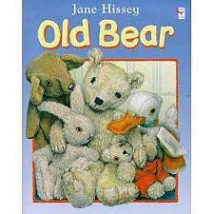 |  |  | 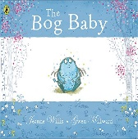 | 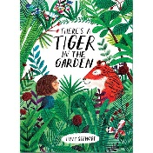 |  | 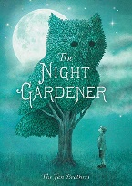 | 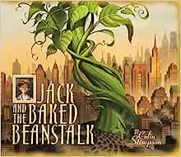 |  | 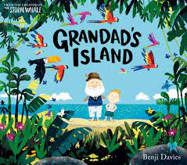 | 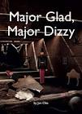 |  | 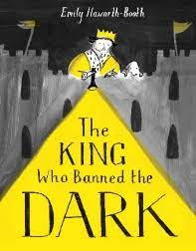 |  | 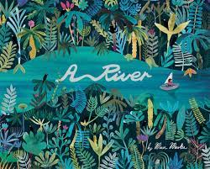 |  | 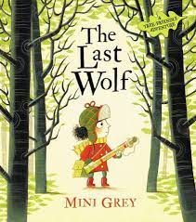 |  | 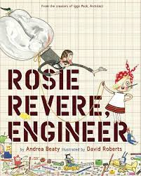
Writing  (Literacy Counts- Read to Write) | Finding Narrative and Letter |  |  | Finding Narrative and Instructions | Return Narrative  and Instructional  Writing |  | Setting  Narrative  and Recounts | Friendship story and information |  | A Return narrative and Explanation | Discovery Narrative and Recounts |  | Mistake Narrative and Information | Traditional Narrative and Instructions | Circular Narrative and Information Texts |  | Hunting Narrative and Instructions |  | Invention Narrative and Explanation
Reading  (Steps to Read) | Living Memory - Toys  (Y1) |  |  | Great Fire of London  (Y2) | Fairy Tales  (Y1) |  | Locality  (Y1) | Traditional Tales and Poetry  (Y2) |  | Stories and Plays and Poetry  (Y2) | Stories and Poems  (Y1) |  | Science - Animals including humans  (Y1) | Fairy Stories  (Y2) | Traditional Tales and Poems  (Y1) |  | Living things  (Y2) |  | Rivers and Seas  (Y2)
Maths  (Power Maths) | Year 1  Power Maths  1A  Numbers to 10  Part Whole within 10  Addition within 10  Subtraction within 10  2D and 3D Shapes  Year 2  Power Maths 2A  Numbers to 100  Addition and  Subtraction 1  Addition and Subtraction 2  Properties of Shape |  |  |  | Year 1  Power Maths  1B  Numbers to 20  Addition and Subtraction  Numbers to 50  Length and Height  Mass and Capacity  Year 2  Power Maths  2B  Money  Multiplication & Division 1  Multiplication & Division 2  Length and Height  Mass, capacity, and Temperature |  |  | Year 1  Power Maths  2C  Multiplication and Division  Fractions  Position and Direction  Numbers to 100  Money  Time  Year 2  Power Maths  2C  Fractions  Time  Problem-Solving and efficient methods  Position and Direction  Statistics |  |  | Year 1  Power Maths  1A  Numbers to 10  Part Whole within 10  Addition within 10  Subtraction within 10  2D and 3D Shapes  Year 2  Power Maths  2A  Numbers to 100  Addition and  Subtraction 1  Addition and Subtraction 2  Properties of Shape |  |  | Year 1  Power Maths  1B  Numbers to 20  Addition and Subtraction  Numbers to 50  Length and Height  Mass and Capacity  Year 2  Power Maths  2B  Money  Multiplication & Division 1  Multiplication & Division 2  Length and Height  Mass, capacity and Temperature |  |  | Year 1  Power Maths  2C  Multiplication and Division  Fractions  Position and Direction  Numbers to 100  Money  Time  Year 2  Power Maths  2C  Fractions  Time  Problem-Solving and efficient methods  Position and Direction  Statistics
Humanities  (Pearson) | History  The Great Fire of London |  |  |  | Geography  Hot and Cold Places |  |  | History  Travel and Transport |  |  | Geography  Weather and Fieldwork Skills |  |  | History  How Should We Remember Pocahontas? |  |  | Geography  Comparing Countries in the UK
PE  + swim | Multi-Skills leading  to Rugby |  |  | Multi-Skills leading to Field Athletics | Dance |  | Multi-Skills leading to Netball | Multi-Skills leading to Track Athletics |  | Multi-Skills leading to Diamond Cricket | Multi-Skills leading to Rugby |  | Multi-Skills leading to Field Athletics | Dance | Multi-Skills leading to Netball |  | Multi-Skills leading to Track Athletics |  | Multi-Skills leading to Diamond Cricket
 | Multi-Skills leading  to Football |  |  | Multi-Skills leading to Gymnastics | Outdoor Adventurous Activities |  | Multi-Skills leading Hockey | Multi-Skills leading to Rounders |  | Multi-Skills leading to Racquet Skills | Multi-Skills leading to Football |  | Multi-Skills leading to Gymnastics | Outdoor Adventurous Activities | Multi-Skills leading to Hockey |  | Multi-Skills leading to Rounders |  | Multi-Skills leading to Racquet Skills
Computing | Grouping data |  | Digital writing |  | Programming animations |  | Pictograms | Digital music |  | Programming quizzes | Technology around us |  | Digital painting | Moving a Robot | Information Technology around us |  | Digital Photography | Robot algorithms
PSHCE  (Kapow) | Families and Relationships |  |  |  | Health and wellbeing |  |  | Safety and the changing body |  |  | Citizenship |  |  | Families and Relationships |  |  | Health and well being
RE  (Shropshire Agreed Syllabus and Understanding Christianity) | Creation  Who made the world? |  |  | Incarnation  1:3 Why does Christmas matter to Christians? | Who is Muslim and how do they live? |  | Why does Easter matter to Christians?  Digging Deeper | Who is Muslim and where do they live? |  | What makes some places scared to Christians? | What is the good news that Jesus brings? |  | Why does Christmas matter to Christians?  (CORE) | Who made the world? | SALVATION  1:2 Why does Easter matter to Christians? |  | How should we care for the world and others and why does it matter?  (C and NR) |  | 1:10 What does it mean to belong to a Christian community?  (C and NR)
Music  (Shropshire Music Service) | Starting Out  Singing and Playing |  |  |  | Beat & Rhythm  Class Composing |  |  | Dynamics  Musical Structures |  |  | Starting Out  Singing and Playing |  |  | Beat & Rhythm  Class Composing |  |  | Dynamics  Musical Structures
Art & Design  (Kapow) | Sculptures and Collages |  |  |  | Formal Elements of Art |  |  | Art and Design Skills |  |  | Human Forms |  |  | Sculpture and Mixed Media |  |  | Landscapes using different media
Design Tech  (Kapow) | Textiles  Puppets |  |  |  | Mechanisms  Wheels and Axles |  |  | Cooking and Nutrition  Preparing Fruit and Vegetables |  |  | Textiles  Pouches |  |  | Structures:  Baby Bears Chair |  |  | Cooking and Nutrition  A Balanced Diet
Science  (Collins-  Snap Science) | Animal Antics  Animals including Humans  (Y1) | Sensing Seasons  Our Changing World  (Y1) |  |  | Good Choices  Everyday Materials  (Y2) | The Apprentice Gardener  Plants  (Y2) |  | Growing Up  Animals including Humans  (Y2) | What is in your Habitat?  Living Things and their Habitats  (Y2) |  | Looking at Animals  Animals including Humans  (Y1) | Using Our Senses  Animals including Humans  (Y1) |  | Shaping Up!  Materials  (Y2) |  | Plant Detectives  Plants  (Y1) | Our Changing World  Living Things and their Habitats  (Y2) |  | Take Care  Animals including Humans  (Y2)

Year 3 & Year 4
2 Year Rolling Plan | Cycle A |  |  |  |  |  |  |  |  | Cycle B
 | Autumn  1 | Autumn  2 |  | Spring  1 | Spring  2 |  | Summer  1 | Summer  2 |  | Autumn  1 | Autumn  2 |  | Spring  1 | Spring  2 |  | Summer  1 | Summer  2
Quality Text Driver | Return | The Journey |  | Egyptology | Leaf |  | Starbird | Seen and Not Heard |  | The Iron Man | The Whale |  | Fox | Manfish |  | Into the Forest | Lost Happy Endings
 | 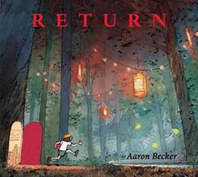 | 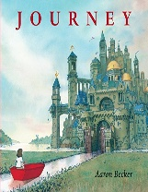 |  | 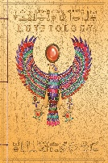 | 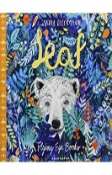 |  | 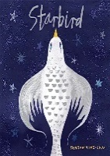 | 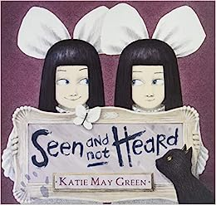 |  | 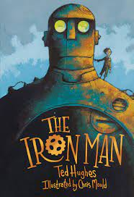 | 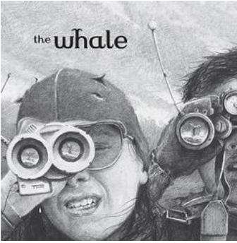 |  | 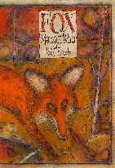 | 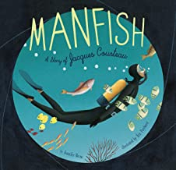 |  | 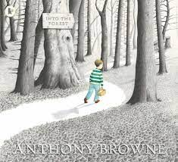 | 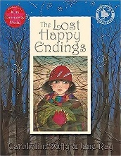
Writing  (Literacy Counts- Read to Write) | Setting Narrative and information Letters | Refugee Narrative and Recounts |  | A Return Narrative and Letter Writing | A Banning Narrative and Letter Wring |  | A Setting Narrative and Information Leaflets | Lost Narrative and Newspaper Reports |  | Finding Narrative  and  Instructional Writing | Invention Narrative  and  Explanation Texts |  | Approach Threat Narrative  and  Explanation  Texts | Fable Narrative  and  Information Texts |  | Setting Narrative  and  Diary Entries | Egyptian Mystery Narrative  and  Reports
Reading  (Steps to Read) | Stories and Plays and Poetry | Traditional Tales and Poems |  | Fairy Stories and Poetry | The Great Fire of London |  | Mountains and Rivers | Stories Different Forms |  | Living things Habitats / Plants | Stories and Plays & Poetry |  | Forces, Magnets and Rocks | Rivers and Seas |  | Fairy Stories and Poetry Classics | Egyptians
Maths  (Power Maths) | Year 3  Power Maths  3A  Place Value to 1000  Addition & Subtraction 1  Addition and Subtraction 2  Multiplication & Division 1  Multiplication & Division 2  Year 4  Power Maths  4A  Place Value – 4 digits (1)  Place Value – 4 digits (2)  Measure-area  Multiplication & Division (1) |  |  | Year 3  Power Maths  3B  Multiplication & Division 3  Length and perimeter  Fractions  Mass  Capacity  Year 4  Power Maths  4B  Multiplication & Division (2)  Length and perimeter  Fractions (1)  Fractions (2)  Decimals (1) |  |  | Year 3  Power Maths  3C  Fractions  Money  Time  Angles and properties of shapes  Statistics  Year 4  Power Maths  4B  Decimals (2)  Money  Time  Geometry- angles and 2D Shapes  Statistics  Geometry- position and direction |  |  | Year 3  Power Maths  3A  Place Value to 1000  Addition & Subtraction 1  Addition and Subtraction 2  Multiplication & Division 1  Multiplication & Division 2  Year 4  Power Maths  4A  Place Value – 4 digits (1)  Place Value – 4 digits (2)  Measure-area  Multiplication & Division (1) |  |  | Year 3  Power Maths  3B  Multiplication & Division 3  Length and perimeter  Fractions  Mass  Capacity  Year 4  Power Maths  4B  Multiplication & Division (2)  Length and perimeter  Fractions (1)  Fractions (2)  Decimals (1) |  |  | Year 3  Power Maths  3C  Fractions  Money  Time  Angles and properties of shapes  Statistics  Year 4  Power Maths  4B  Decimals (2)  Money  Time  Geometry- angles and 2D Shapes  Statistics  Geometry- position and direction
Geography  (Pearson) | Villages, Towns and Cities |  |  | Mountains, Volcanoes and Earthquakes |  |  | Water and weather |  |  | Rivers |  |  | Migration |  |  | Natural Resources
History  (Pearson) |  | Prehistoric Britain |  |  | Shang Dynasty |  |  | Ancient Greece |  |  | Roman Britain |  |  | Anglo-Saxons |  |  | Vikings
PE  + swim | Tag Rugby | Field Athletics |  | Dance | Netball |  | Track Athletics | Kwik Cricket |  | Tag Rugby | Field Athletics |  | Dance | Netball |  | Track Athletics | Kwik Cricket
 | Football | Gymnastics |  | Outdoor Adventure | Hockey |  | Rounders | Tennis |  | Football | Gymnastics |  | Outdoor Adventure | Hockey |  | Rounders | Tennis
Computing | Branching Databases |  | Desktop Publishing | Repetition in Shapes |  | Data Logging | Photo Editing |  | Repetition in Games | Connecting |  | Stop Frame | Sequencing |  | The Internet | Audio Production | Events and Actions
PSHCE  (Kapow) | Families and Relationships |  |  | Health and well being |  |  | Safety and the changing body |  |  | Citizenship |  |  | Families and Relationships |  |  | Health and wellbeing
RE  (Shropshire Agreed Syllabus and Understanding Christianity) | What kind of world did Jesus want? | What is the Trinity? |  | How do festivals and worship show what matters to be a Muslim? | Salvation  Why do Christians call the day Jesus dies Good Friday? |  | When Jesus left what was the impact of Pentecost? | How and why do people try and make the world a better place? |  | CREATION  2a.1  What do Christians learn from the Creation Story?  DIGGING DEEPER | INCARNATION  2a.3  What is The Trinity?  DIGGING DEEPER |  | L2.10  How do festivals and family life show what matters to Jewish people? | SALVATION  Why do Christians call the day Jesus died Good Friday?  CORE |  | LDBE  How do people express their faith through the arts?  (Spirited arts focus) | PEOPLE OF GOD  2a.1  What is it like to follow God?  CORE
Music  N  (Shropshire Music service) | Percussion |  |  | Guitar |  |  | Blues and Pitch Skills |  |  | Ukuele |  |  | Sea Shanties  Pitch Skills |  |  | Folk Whistle
Music  W  (Shropshire Music service) | The Blues |  |  | Percussion |  |  | Guitar |  |  | Folk Whistle |  |  | Ukulele |  |  | Sea Shanties  Pitch Skills
Art & Design  (Kapow) | Craft |  |  | Formal elements of art |  |  | Art and Design skills |  |  | Every picture tells a Story |  |  | Sculpture |  |  | Prehistoric Art
Design Tech  (Kapow) | Textiles  Cushions |  |  | Mechanical Systems  Making a Slingshot Car |  |  | Cooking and Nutrition  Adapting a Recipe |  |  | Textiles  Fastenings |  |  | Structures  Pavillions |  |  | Cooking and Nutrition
MFL  (Kapow)) | French greetings with Puppets |  | French adjectives of colour, size, and shape | Playground games Numbers and Age |  | In a French Classroom | Bon Appetit! |  | Shopping for French Food | This Is Me |  | School Days | Birthday Celebrations | Colourful Creatures – Animals Colour and Size |  | Fabulous French Food | Gourmet Tour of France
Science  Collins  Snap Science | The Power of Forces  Forces and Magnets  (Y3) |  | In a State  States of Matter  (Y4) | Our changing world  Living things and their Habitat  (Y3) |  | Our changing world  Living things and their Habitat  (Y4) | Amazing Bodies  Animals Including Humans  (Y3) |  | Good Vibrations  Sound  (Y4) | Rock detectives  Rocks  (Y3) |  | Can you see me?  Light  (Y3) | Switched on!  Electricity  (Y4) | Where does all that food go?  Animals Including Humans  (Y4) |  | How does your garden Grow?  Plants  (Y3) | Who am I?  Animals Including Humans  (Y4)

Year 5 & Year 6
2 Year Rolling Plan | Cycle A |  |  |  |  |  |  |  |  |  |  |  | Cycle B
 | Autumn  1 | Autumn  2 |  |  | Spring  1 |  | Spring  2 |  | Summer  1 |  |  | Summer  2 | Autumn  1 |  |  | Autumn  2 | Spring  1 | Spring  2 | Summer  1 |  | Summer  2
Quality Text Driver | King Kong | Origin of Species |  |  | Henry’s Freedom Box |  | Anne Frank |  | Wild is the Wind |  |  | Dreams of Freedom | Farther |  |  | Rose Blanche | The Errand | A Story Like the Wind | The Ways of The Wolf |  | Rise Up
 | 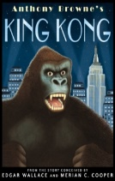 | 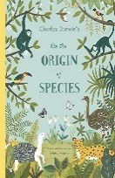 |  |  | 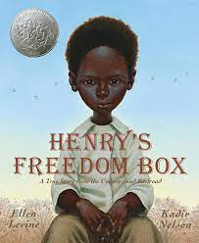 |  | 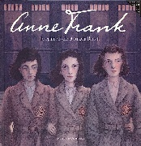 |  | 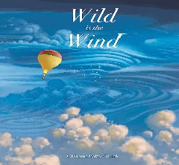 |  |  | 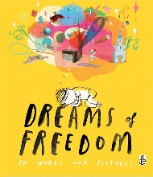 | 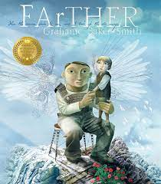 |  |  | 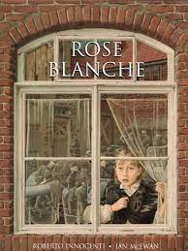 | 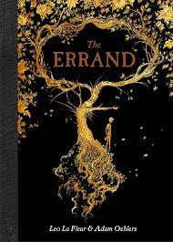 | 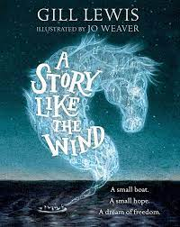 | 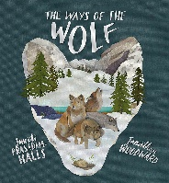 |  | 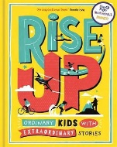
Writing  (Literacy Counts- Read to Write) | Dilemma Narrative and Balanced Arguments | Discovery Narrative and Explanation |  |  | Diary and Biography |  | Diary and Bravery award Speech |  | Endurance  Narrative,  Recounts and Magazine Articles |  |  | Letters and Freedom Narrative | Settings and Letters |  |  | Diary and Bravery Award Speech | Cliff-hanger Narrative and Instruction Manuel | Flashback Narrative and Newspaper Report | First Person Description, Suspense Narrative, Balanced Argument, Information Text |  | Newspaper Report
Reading  (Steps to Read) | Modern Fiction (Y5) | Science- Evolution  (Y6) |  |  | Victorians  (Y5) |  | Traditional tales and poetry  (Y6) |  | Geography America  (Y5) |  |  | Traditional Tales and Poetry  (Y6) | Space (Y5) |  |  | War  (Y6) | Other Cultures and Traditions and Poetry  (Y5) | Geography Coasts  (Y6) | Literary Heritage  Play and Poetry  (Y6) |  | Modern Fiction  (Y6)
Maths  (Power Maths) | Year 5  Power Maths  5A  Place Value within 1.000.000 (1)  Place Value within 1.000.000 (2)  Addition & Subtraction  Multiplication & Division 1  Fractions (1)  Fractions (2)  Year 6  Power Maths  6A  Place Value within 10.000.000  Four Operations (1)  Four operations (2)  Fractions (1)  Fractions (2)  Measure- Imperial and Metric M |  |  |  | Year 5  Power Maths  5B  Multiplication & Division (2)  Fractions (3)  Decimals and Percentages  Perimeter and Area  Graphs and Tables  Year 6  Power Maths  6B  Ratio and Proportion  Algebra  Decimals  Percentages  Measure-Perimeter, area and volume. |  |  |  | Year 5  Power Maths  5C  Geometry of Shapes  Geometry- Position and direction  Decimals  Negative Numbers  Measure- Converting units  Measure-Volume  Year 6  Power Maths  6C  Statistics  Geometry-Properties of shapes  Geometry-Position and Direction  Problem Solving |  |  |  | Year 5  Power Maths  5A  Place Value within 1.000.000 (1)  Place Value within 1.000.000 (2)  Addition & Subtraction  Multiplication & Division 1  Fractions (1)  Fractions (2)  Year 6  Power Maths  6A  Place Value within 10.000.000  Four Operations (1)  Four operations (2)  Fractions (1)  Fractions (2)  Measure- Imperial and Metric Measure |  |  |  | Year 5  Power Maths  5B  Multiplication & Division (2)  Fractions (3)  Decimals and Percentages  Perimeter and Area  Graphs and Tables  Year 6  Power Maths  6B  Ratio and Proportion  Algebra  Decimals  Percentages  Measure-Perimeter, area and volume. |  | Year 5  Power Maths  5C  Geometry of Shapes  Geometry- Position and direction  Decimals  Negative Numbers  Measure- Converting units  Measure-Volume  Year 6  Power Maths  6C  Statistics  Geometry-Properties of shapes  Geometry-Position and Direction  Problem Solving
Geography  (Pearson) | Slums |  |  |  | Biomes |  |  |  | Energy and Sustainability |  |  |  | Local Field Work |  |  |  | Population |  | Globalisation
History  (Pearson) |  | Industrial Revolution |  |  |  |  | Civil Rights |  |  |  |  | 20th Century Conflict |  |  |  | Benin Kingdom |  | Medieval Monarchs |  |  | Changing Britain
PE | Tag Rugby | Field Athletics |  |  | Dance |  | Netball |  | Track Athletics |  |  | Kwik Cricket | Tag Rugby |  |  | Field Athletics | Dance | Netball | Track Athletics |  | Kwik Cricket
 | Football | Gymnastics |  |  | Outdoor Adventure |  | Hockey |  | Rounders |  |  | Tennis | Football |  |  | Gymnastics | Outdoor Adventure | Hockey | Rounders |  | Tennis
Computing | Flat File databases |  |  | Introduction to Vector Graphs | Selection in Quizzes | Introduction to Spreadsheets |  |  | 3D Modelling | Sensing Movement |  |  | Systems and searching |  | Video Production |  | Selection in Physical computing | Communication and Collaboration | Webpage Creation | Variables in games
PSHCE  (Kapow) | Families and relationships |  |  |  | Health and wellbeing |  |  |  | Safety and the changing body |  |  |  | Citizenship |  |  |  | Families and relationships |  | Health and well being
RE  (Shropshire Agreed Syllabus and Understanding Christianity) | Creation and science: conflicting or complimentary? | Was Jesus the Messiah? |  |  | What does it mean to be a Muslim in Britain today? |  | What did Jesus do to save human beings? |  | How do people express their faith through the arts? |  |  | How does faith help people when life gets hard? | PEOPLE OF GOD  2b.3 How can following God bring freedom and justice?  CORE |  |  | U2.11  Why do some people believe in God and some people not?  (C, NR) | U2.9  Why is the Torah so important to Jewish people? | SALVATION  2b.6 What difference does the resurrection make for Christians?  CORE | LDBE  How do people express their faith through the arts?  (Spirited arts focus) |  | KINGDOM OF GOD  2b.8 What kind of King is Jesus?  CORE
Music N | Percussion |  |  |  | Guitar |  |  |  | The Blues |  |  |  | Folk Whistle |  |  |  | Sea Shanties |  | Guitar
Music W | The Blues |  |  |  | Percussion |  |  |  | Guitar |  |  |  | Sea Shanties |  |  |  | Folk Whistle |  | Ukulele
Art & Design | Design for a Purpose |  |  |  | Art and Design Skills |  |  |  | Make my voice heard |  |  |  | Photography |  |  |  | Still Life |  | Every Picture tells a story
Design Tech  (Kapow) | Structures  Bridges |  |  |  | Mechanical Systems  Automata Toys |  |  |  | Cooking and Nutrition  Come Dine with me |  |  |  | Textiles  Stuffed Toys |  |  |  | Electrical Systems  Steady Hand Game |  | Cooking and Nutrition
MFL  (Kapow) | Portraits Describing in French |  | Meet My French family |  | Clothes- getting dressed |  |  | French Weather | Exploring the French Speaking World |  | Planning a French Holiday |  | French Transport | In My French House |  |  | Music in France | French Verbs in a Week | Visiting a Town in France |  | French sport and the Olympics
Science  (Collins  Snap Science) | Reproduction in Plants and Animals  Animals Including humans  (Y5) |  | Get Sorted  Materials  (Y5) |  | Everything changes  Animals Including humans  (Y6) |  |  | Light up your World  Light  (Y6) | Danger Low Voltage  Electricity  (Y6) |  | Marvellous Mixtures  (Y5) |  | Everyday Materials  Materials  (Y5) | The Earth and Beyond  Earth and Beyond  (Y5) |  |  | Feel the Force  Forces  (Y5) | The Nature Library  Living Things and their Habitats  (Y6) | Our Changing World  Animals Including Humans  (Y6) |  | Body Pump  Animals Including Humans  (Y6)

