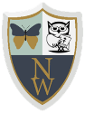
Newhampton Church of England Primary School Science Knowledge Organiser

Unit: Our Changing World- Sensing Seasons Focus: Seasonal Changes, Animals, including humans and Plants