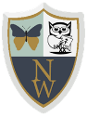
Newhampton Church of England Primary School Science Knowledge Organiser
Unit: Looking at animals Focus: Animals, including humans and Plants
